- What is the energy (in joules) of one mole of photons with a wavelength 658 nm?

E = hc/ where,
h = Planck's constant = 6.626 x 10⁻³⁴ J.s
c = speed of light in vacuum = 3 x 10⁸ m/s
= wavelength of light = 658 nm = 658 x 10⁻⁹ m
Hence the energy of 1 photon of wavelength of 658 nm,
E = (6.626 x 10⁻³⁴)(3 x 10⁸)/(658 x 10⁻⁹) = 3.02 x 10⁻¹⁹ J
1 mol of photon = 6.02 x 10²³ photons
Energy of 1 mole = 3.02 x 10⁻¹⁹ J x 6.02 x 10²³/mol = 1.82 x 10⁵ J/mol

- In 2-3 sentences, explain the significance of De Broglie’s Hypothesis and the Heisenberg Uncertainty Principle in the development of Schrodinger’s model of the atom.
De Broglie proposed that any particle that has momentum has also wave like nature. The wavelength of a matter wave associated with a particle is inversely proportional to the magnitude of the particle's linear momentum. As electron a subatomic particle moving around the nucleus, it should obey both De Broglie and Heisenberg uncertainty principle. Hence Schrodinger in in his quantum mechanical model proposed that, electrons moving around the nucleus in a wave like motion called 'orbitals'

- The probability density map of a 1s orbital is pictured below. Define the term orbital and explain what probability density represents.
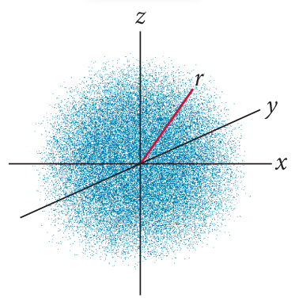

- What is the difference between one of Schrodinger’s orbitals and one of Bohr’s orbits?
In Schrodinger’s Theory quantum systems are regarded as wave functions which solve the Schrodinger equation whereas in the old quantum theory of Bohr - the underlying assumptions are only suited for single electron atom and the assumptions as quantum conditions are put in an arbitrary manner.

- Sketch a 2p orbital. How would a 3p orbital differ from a 2p orbital? Explain.
The two are different in terms of the direction they face in the space. They are also different in terms of the size, energy and number of nodes which they have.

- Write the electron address of an electron in a 1s orbital. ______1s¹___________________

- Label each of the following sets of quantum numbers as a VALID or INVALID address for an electron in an atom. For each answer (a – c), explain why it is either valid or invalid.

  - [4, 0, 1, +1/2] invalid. It has no similar orbitals which have opposing spins.

  - [3, 1, 1, -1/2] valid.

  - [2, 2, -2, +1/2] valid because it has electrons which the same electron quantum numbers.

- The characteristics of an orbital are defined by the first three quantum numbers (principle, angular momentum, and magnetic), while the spin quantum number determines the maximum number of electrons in an orbital. What is the maximum number of electrons allowed in any orbital, and what does the Pauli exclusion principle tell us about the behavior of the electrons in an orbital.
the principles argues that a molecule or an atom and no two electrons would be having a similar electron quantum number. An orbital therefore can only have a maximum of two electrons only and both of them must be of opposing spins.

- Some orbital types (i.e., p, d, and f) exists as multiple orbitals. Orbitals of one type are referred to as a sublevel (so long as they have the same principle quantum number). Determine the maximum number of electrons that can exist in each sublevel (s, p, d, and f) by filling in the following table:

Sublevel | Number of orbitals allowed in sublevel | Number of electrons allowed per orbital | Total number of electrons in sublevel
s | 1 | 2 | 2 e⁻
p | 3 | 6 | 6 e⁻
s | 5 | 2 | 2
f | 7 | 14 | 7

- Why are atoms usually portrayed as spheres when most orbitals are not spherically shaped?
Many atoms have various electrons which occupy a number of different orbitals and therefore the shape of the atom is usually obtained through superimposing all the orbitals it contains.

